*\ -'ff\()*

WHEN RECORDED, **MAIL** TO:

Utah Department of Transportation Right of Way, Fourth Floor

Box 148420

Salt Lake City, Utah 84114-8420

**Warranty Deed**

(LIMITED-PARTNERSHIP)

Uintah County

Affecting Tax ID No. 05-132-0061

and 05-132-0145

PIN No. 20956

Project No. F-2805(3)1 Parcel No. 100:TC

BASCOM INVESTMENTS, LP., a Limited-Partnership of the State of Utah, Grantor, whose current address is 195 North 100 East, Bountiful, Utah 84010, hereby CONVEYS AND WARRANTS to the CITY OF NAPLES, Grantee, at 1420 East 2850 South, Naples, Utah 84078, for the sum of TEN ($10.00} Dollars, and other good and valuable considerations, the following described parcel of land in Uintah County, State of Utah, to-wit:

A parcel of land in fee for the construction of a trailhead for Naples City park trail, incident to the Utah Department of Transportation Project No. F-2805(3) 1, being an entire tract, situate in Lot 2 (SW1/4NW1/4) of Section 31, T.4S., R.22E., S.L.B.&M. The boundary of said parcel of land is described as follows:

Beginning at a point in the North line of said Lot 2, said point being 260.00 feet East from the Northwest corner of said Lot and running thence East 180.00 feet along the North line of said Lot, thence S.00°04'13"W. (South by record) 165.00 feet parallel with the West line of said Lot, thence West 400.00 feet parallel with the North line of said Lot more or less to a point in the easterly existing right of way line of U.S. Highway 40, thence N.00°04'13"E. (North by record) 82.00 feet along said easterly existing right of way line, thence East 220.00 feet parallel with the North line of said Lot, thence

Continued on Page 2

LIMITED-PARTNERSHIP RW-01LP (11-01-03)

Page2 PIN No. 20956

Project No. F-2805(3)1 Parcel No. 100:TC

N.00°04'13"E. (North by record) 83.00 feet parallel with the West line of said Lot to the point of beginning as shown on the official map of said project on file in the office of the Utah Department of Transportation. The above-described parcel of land contains a total of 1.096 acres, or 47,740 square feet, more or less.

(Note: Rotate all bearings in the above description 02°10'14" counter-clockwise to obtain project bearings.)

sTATE oF U-t?A.n )

)ss.

COUNTY OF 9-t+ uzt::e,)

BASCOM INVESTMENTS, L.P.

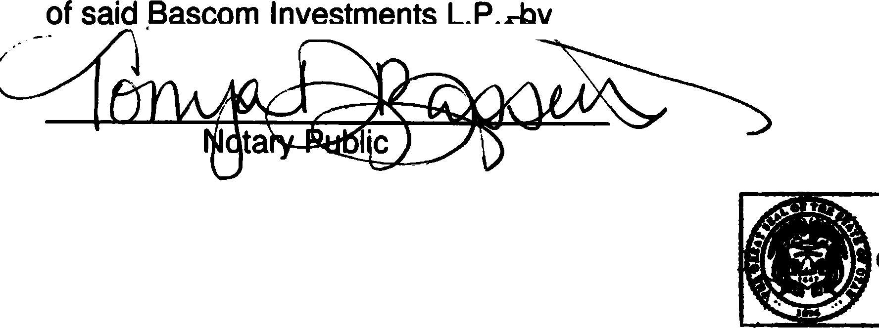

\ _.'\,A N O . lo ,

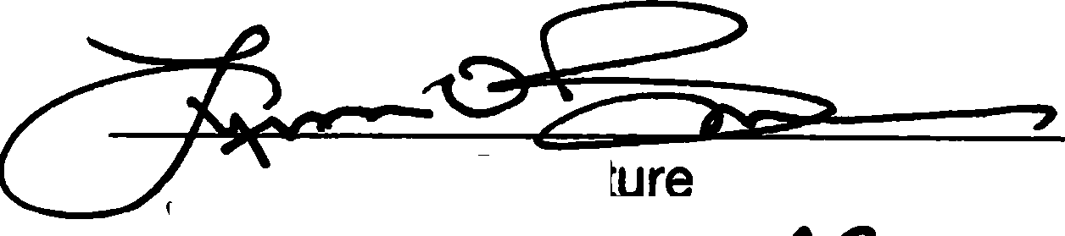

Signa

1 Print Name and Title *Ytner'"*

On this 3\ 91- day of *c::x;:::..:,tp* , in the year 20 2-t..\- , before me personally appeared 4_¥1n 0. 'Bli'l ,whose identity

is personally known to me (or proven in the basis of satisfactory evidence) and who by me being duly sworn/affirmed, did say th@he is the -----',J------e,>(" ===-------

of Bascom Investments, L.P., and that said document was signed b hi Vher on behalf

-===:..:...:.:..:..:.=.=::..:..:.:.; =.:....::.7'... Authority of its Ce-r-nfi of ),dfryi

°'-vtl"\tr p

**TONYA D BASSETT**

**Notaly Public** - **Stat& of Utah Commission Number: 731018 My Cornmlsaion Expires on May5.2027**

Prepared by: DWP of CIVCO Engineering, Inc 6/19/2024 - 01P LIMITED PARTNERSHIP RW-01LP (11-01-03)

RESOLUTION NO. 24-361

A RESOLUTION OF THE CITY COUNCIL OF NAPLES CITY APPROVING OWNERSHIP OF.REAL PROPERTY FORTHE NAPLES TRAIL PROJECT

WHEREAS, the Utah Department ofTransport•lon(UDOT) has undertaken Project F- 2805(3)1i. known as the Naples Trafl Project1 to enhance transportation infrastructure in Naples City; and

WHEREAS, all funds used to purchase the properties at issue herein are provided by UOOT, and Naples City is not contributing financial resources toward the acquisition: and

WHEREAS, Naples City is required to accept own8r$hip of the properties acquired for the project to fulfill the administrative and legal requirements necessary for the implementation of the Naples Trail Project; and

NOW, THEREFORE, BE IT RESOLVED by the City Council of Naples City, Utah:

1. The following properties have been·acquired forright-of.;way purposes and are to

be accepted by Naples City as the Grantee•: •

* + Property #1: Located at 1773 South 1500 East, Naples; Utah 84078, Serial #051320061. Legal Description: BEG 260 FT E OF NW COR SW/4 NW/4 SEC 31, T4S, R22E, SLM TH E 180,31 FT M/L; TH S 165 FT; TH W 180.73 FT M/L; TH N 69 FT; TH W 220 FT; TH N 15 FT; TH E 220 FT; TH N 83 FT TO POB. CONT0.75 ACRES.
  + Property #2: Located at 1749 South 1500 East, Naples, Utah, Serial #051320145. Legal Description: 8EG AT A PT 96 Fi S AND 40 FT E OF THE NW COR SW/4 NW/4 OF SEC 31. T4S, R22E, SLM; AND RUN TH S 69 FT; TH E 220 FT; TH N 69 FT; TH W 220 FT TO **POB.** CONT 0.35 ACRE, M/L.

1. Naples City hereby accepts ownership of the properties described above. The current intended purpose is ln relation to UOOT Projftct F.;;2805(3)1, the Naples Trail Project.
2. Naples City authorizes the Uintah County Recorder's Office to accept and record the Warranty Deeds submitted for the abovEt-described properties, reflecting Naples City as the new owner or vested interest holder. •
3. This resolution shall take effeGt immediately upon its ,adoption. PASSED AND APPROVED this 12th day of[)ecember, 2024.

NAPLES CITY COUNCIL

**By:JZ:{Jf'-**

0,-(A.Baker ayoi

ATTEST:

