FOR FILE #177865-CAU

PARCEL 1A:

The non-exclusive easement for locating, constructing, improving, grading, landscaping and other necessary work, appurtenant to PARCEL 1, as created in and governed by that certain Temporary Construction Easement recorded November 8, 2023 as Entry No. 1212129 in Book 2800 at Page 902 in the office of the Summit County Recorder, State of Utah, as corrected and amended by that certain recorded as Entry No. in Book at Page in the office of the Summit County Recorder, State of ah, over, through, and under the following described tract:

BEGINNING AT THE NORTHEAST CORNER LOT 1, UBER RECORDED JULY 9, 2024, AS ENTRY NO. 1222337 IN B THE SUMMIT COUNTY RECORDER, AND RUNNING THENCE SOUTH 0°16'14" WEST 558.90 FEET TO TANGENT RADIUS CURVE TO THE LEFT; THE

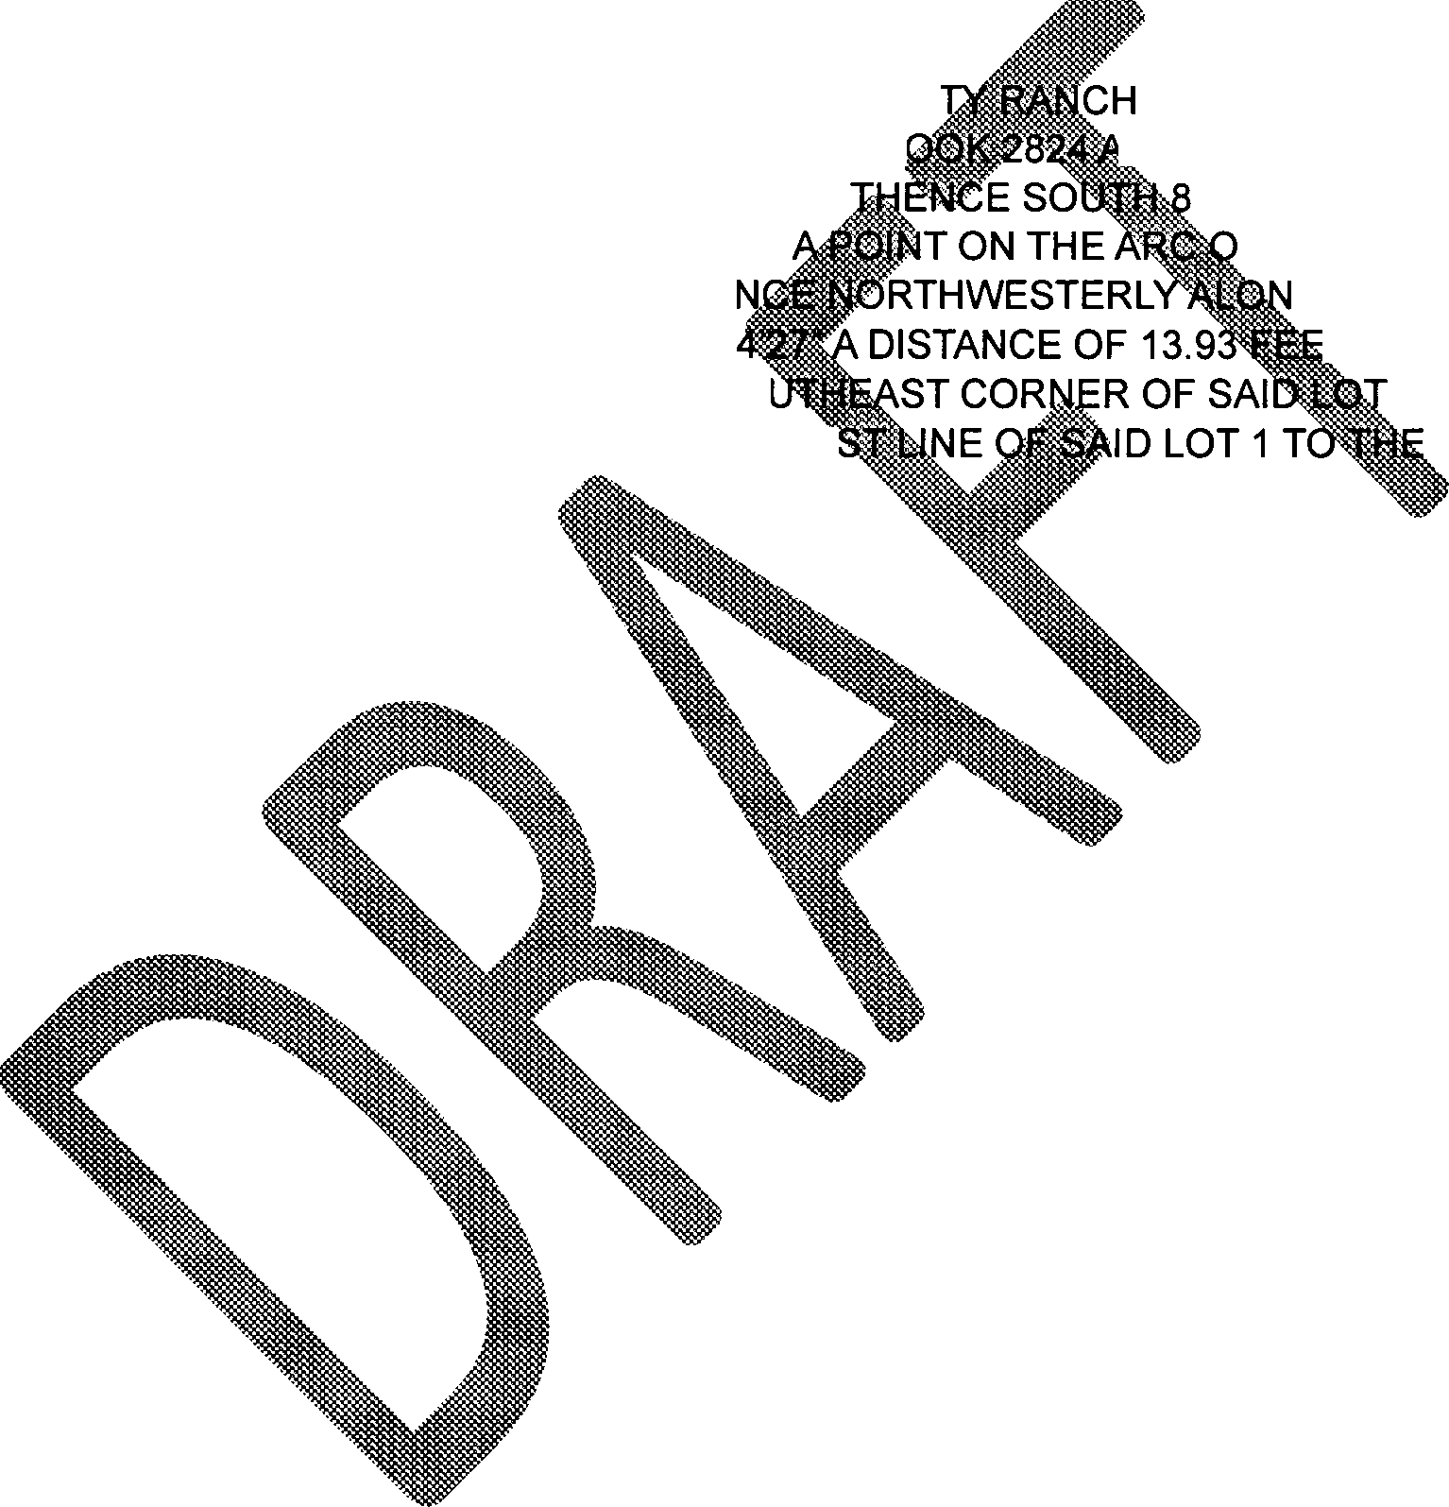CURVE THROUGH A CENTRAL ANGLE OF 1°4 NORTH 59°11'16" WEST 13.93 FEET TO THE SO NORTH 0°16'14" EAST 551.84 FEET ALONG THE EA BEGINNING.

AT STAR POINT, AS

:r PAGE 1907 IN THE OFFICE OF 9° 35'56" EAST 12.00 FEET;

FA 458.60 FOOT NON G THE ARC OF SAID

T, CHORD BEARS 1; THENCE

POINT OF